**L. VARSHINI**

**192372045**

**CSA1618 DWDM**

**EXPERIMENT-25**

**FREQUENT PATTERN MINING USING ASSOCIATION RULE THROUGH WEKA AND R TOOLS**

**AIM:**

To create frequent pattern mining using association rule through weka and R-tools.

**PROCEDURE:**

1. Download and install WEKA.
2. Open WEKA and Choose "Explorer" from the main menu.
3. Under Preprocess, Click on the open file button and select the dataset. Ensure that categorical attributes are in the correct format (nominal, not numeric).
4. Go to the **"Associate"** tab for association rule mining.In the **"Associate"** tab, click **"Choose"** and select ‘apriori’.
5. Click on **"Apriori"** to configure: **minMetric:** Set the minimum confidence

(default=0.9), **numRules:** The number of association rules to generate (default = 10),**lowerBoundMinSupport:** Minimum support value (default = 0.1, or 10%), **upperBoundMinSupport:** Adjusts the range for frequent itemsets.

1. Click **"OK"** and then **"Start"** to begin clustering. Save the file.

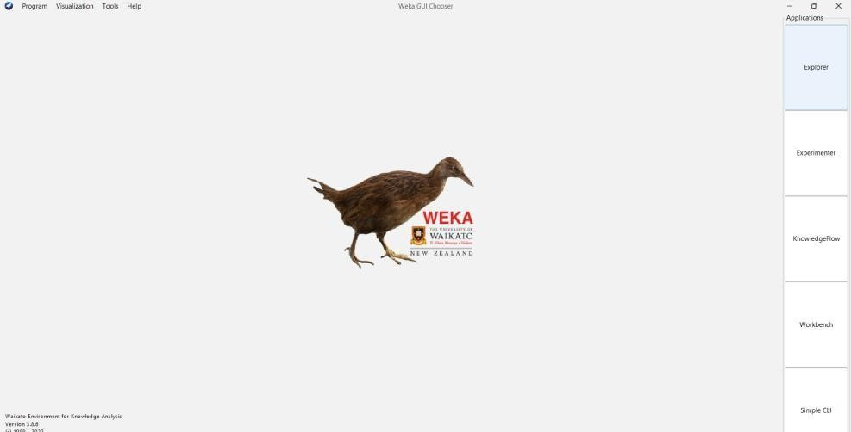

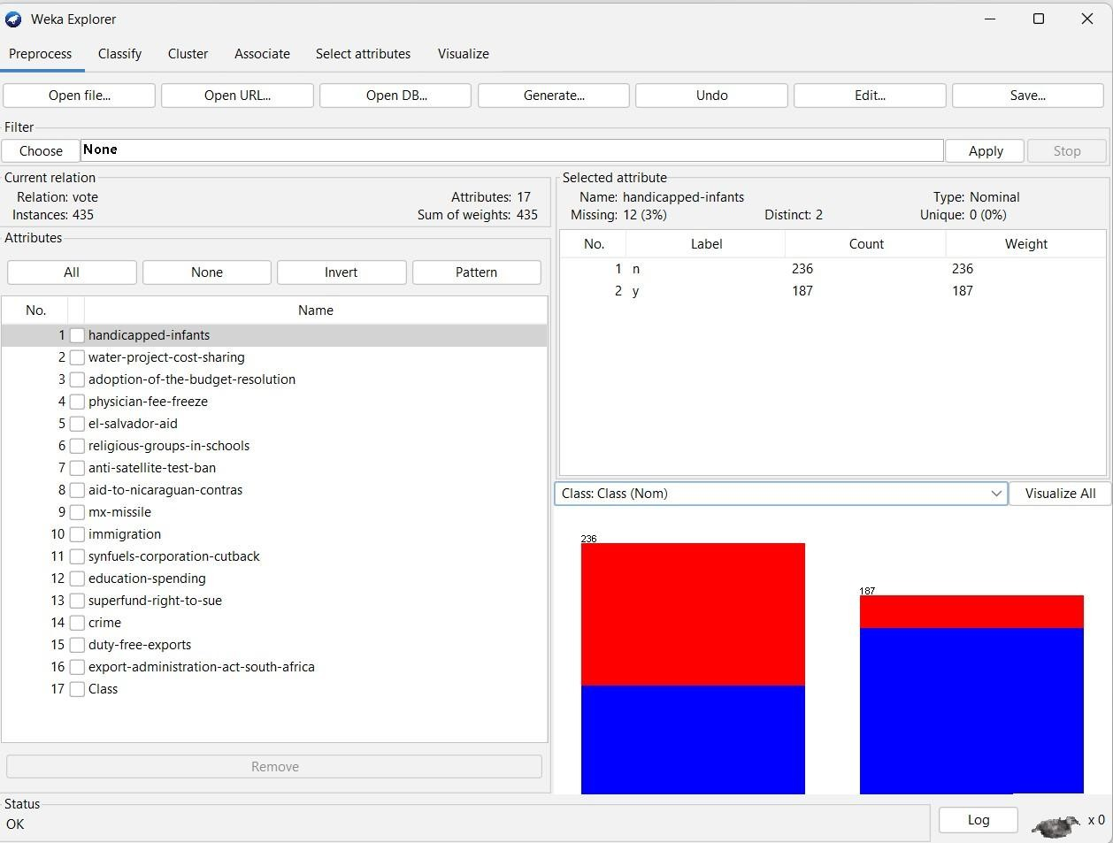

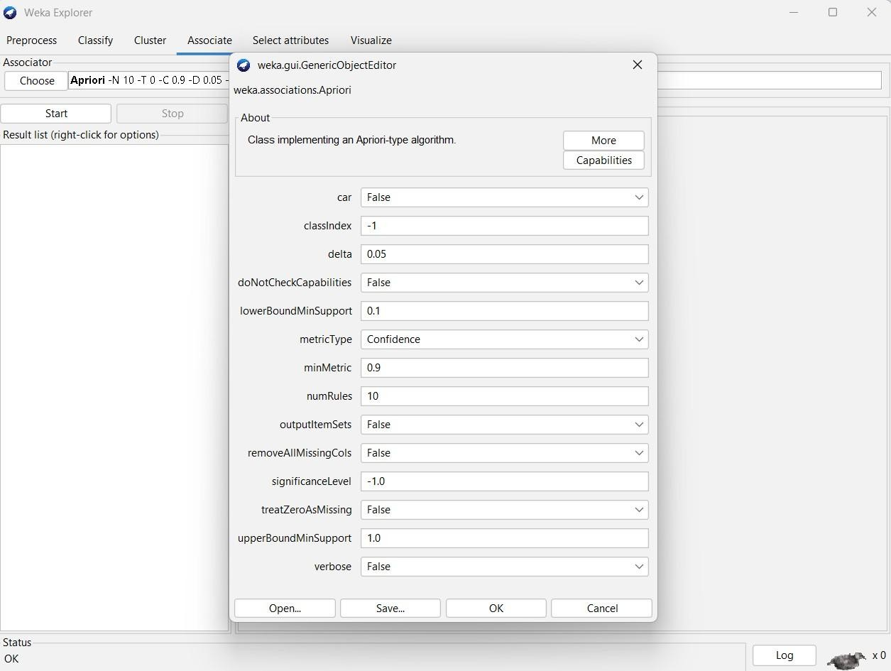

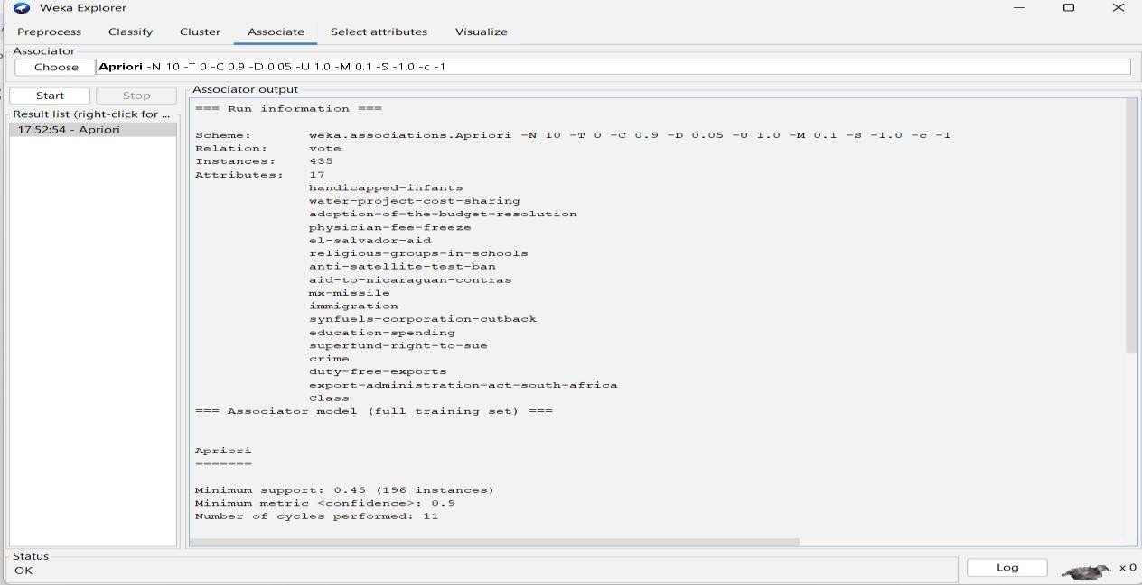

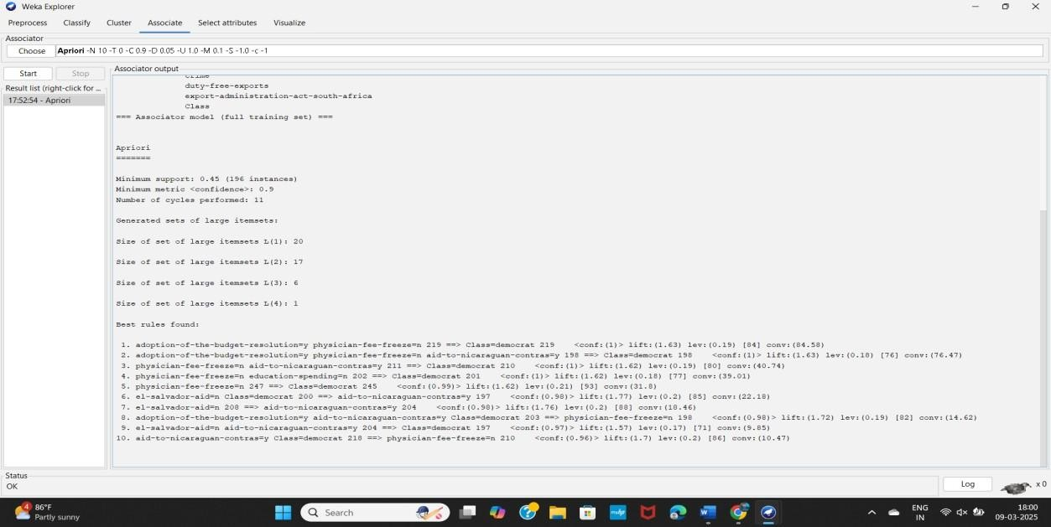

**OBSERVATION:**

**Apriori**

Minimum support: 0.45 (196 instances)

Minimum metric <confidence>: 0.9

Number of cycles performed: 11 Generated sets of large itemsets:

Size of set of large itemsets L(1): 20

Size of set of large itemsets L(2): 17 Size of set of large itemsets L(3): 6 Size of set of large itemsets L(4): 1 **Best rules found:**

1. adoption-of-the-budget-resolution=y physician-fee-freeze=n 219 ==> Class=democrat 219

<conf:(1)> lift:(1.63) lev:(0.19) [84] conv:(84.58)

1. adoption-of-the-budget-resolution=y physician-fee-freeze=n aid-to-nicaraguan-contras=y 198 ==> Class=democrat 198 <conf:(1)> lift:(1.63) lev:(0.18) [76] conv:(76.47)
2. physician-fee-freeze=n aid-to-nicaraguan-contras=y 211 ==> Class=democrat 210 <conf:(1)> lift:(1.62) lev:(0.19) [80] conv:(40.74) 4. physician-fee-freeze=n education-spending=n 202 ==> Class=democrat 201 <conf:(1)> lift:(1.62) lev:(0.18) [77] conv:(39.01)
3. physician-fee-freeze=n 247 ==> Class=democrat 245 <conf:(0.99)> lift:(1.62) lev:(0.21) [93] conv:(31.8)
4. el-salvador-aid=n Class=democrat 200 ==> aid-to-nicaraguan-contras=y 197 <conf:(0.98)> lift:(1.77) lev:(0.2) [85] conv:(22.18)
5. el-salvador-aid=n 208 ==> aid-to-nicaraguan-contras=y 204 <conf:(0.98)> lift:(1.76) lev:(0.2) [88] conv:(18.46)
6. adoption-of-the-budget-resolution=y aid-to-nicaraguan-contras=y Class=democrat 203 ==> physician-fee-freeze=n 198 <conf:(0.98)> lift:(1.72) lev:(0.19) [82] conv:(14.62)
7. el-salvador-aid=n aid-to-nicaraguan-contras=y 204 ==> Class=democrat 197 <conf:(0.97)> lift:(1.57) lev:(0.17) [71] conv:(9.85)
8. aid-to-nicaraguan-contras=y Class=democrat 218 ==> physician-fee-freeze=n 210 <conf:(0.96)> lift:(1.7) lev:(0.2) [86] conv:(10.47)

**RESULT:**

Thus, the Apriori algorithm analyzing using both the weka tool and R- tool has been successfully completed. In case of weka tool, the change in upper bound and lower bound values lead to the increase and decrease of number of itemsets and rules . In case of R-tool, there is an increase in absolute minimum support count value.